Troubleshooting Tools
Q1.Open the command prompt and use the ipconfig tool to find your computer's IPv4 address and default gateway, then take a screenshot of the output.
Ans:

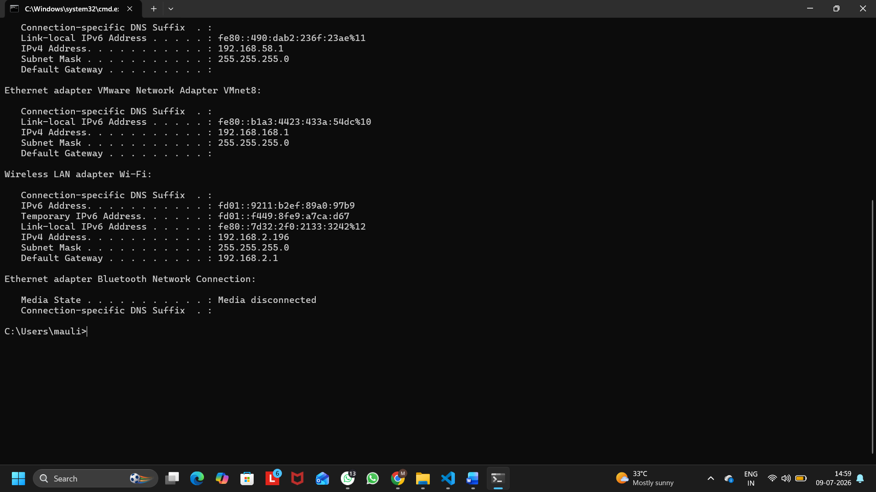
Figure 1: Output of the ipconfig Command Showing IPv4 Address and Default Gateway
Observed Values:
IPv4 Address: 192.168.2.196
Default Gateway: 192.168.2.1

Q2. Use the ping command to check the connectivity between your computer and www.google.com, then note down the average response time shown.
Ans:
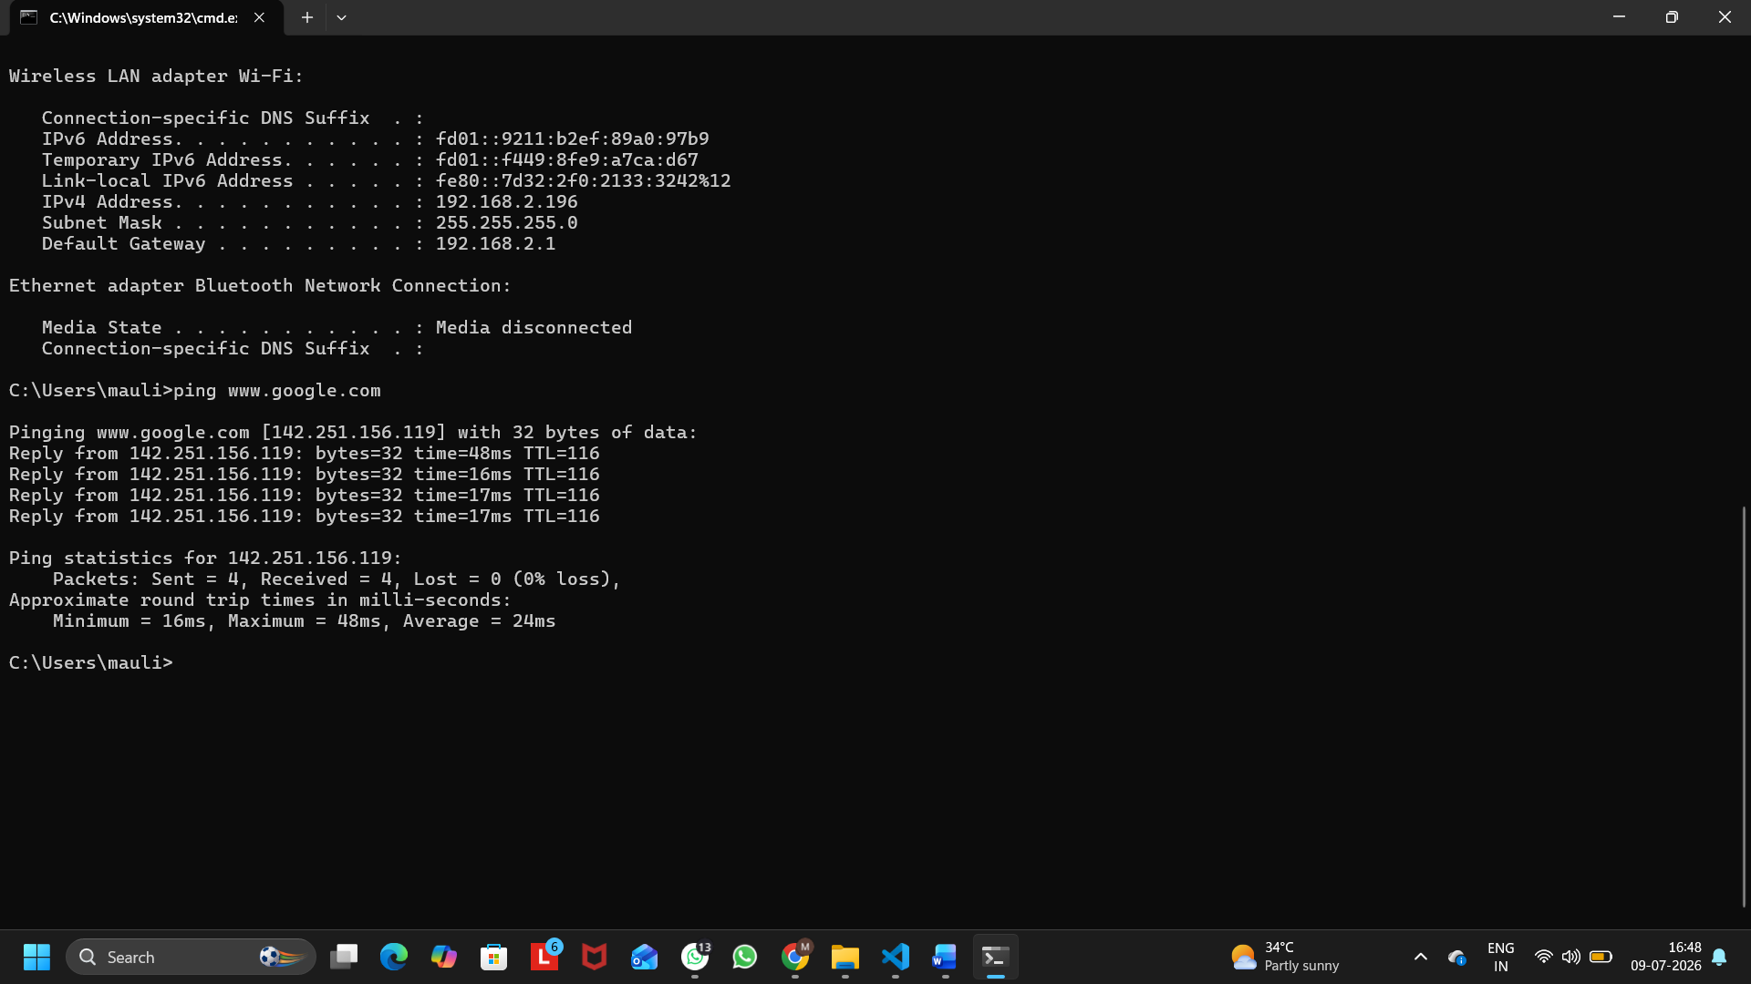
Figure 1: Output of the Ping Command for www.google.com
Average = 24 ms
Q3. Run the tracert (or traceroute on Linux/Mac) command to www.flipkart.com and list the number of hops it takes to reach the destination.
Ans:
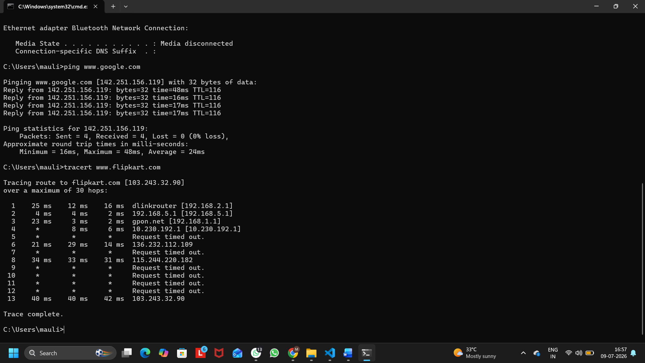
Figure 1: Output of the Tracert Command for www.flipkart.com
The tracert command was used to trace the network path from my computer to www.flipkart.com. The destination was successfully reached in 13 hops.

Q4. Use the nslookup tool to find the IP address of www.spotify.com and explain in one line what this tool helps you verify.
Ans:
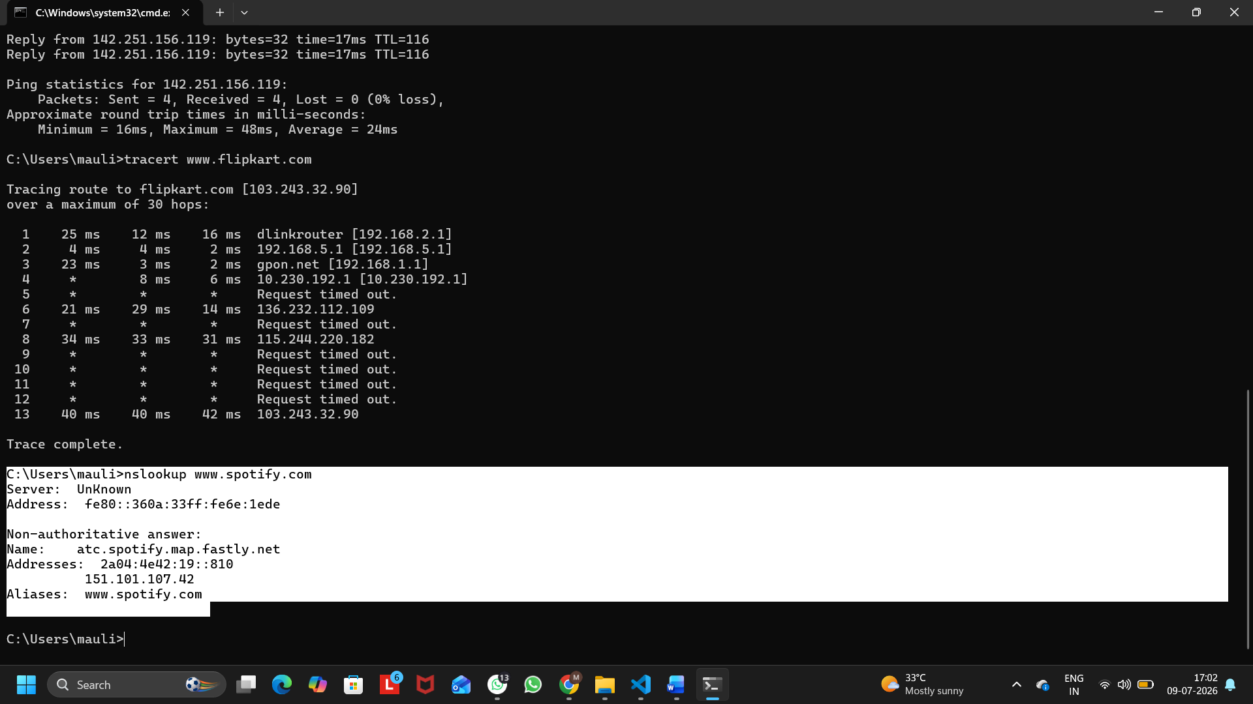
Figure 1: Output of nslookup Command for www.spotify.com
IP Address of www.spotify.com: 151.101.107.42
Explanation: The nslookup command checks whether a domain name is correctly translated into its IP address by the DNS server.

Q5. A friend says they cannot access Zomato’s website from their laptop. Suggest a sequence of three troubleshooting commands (choose from: ping, ipconfig, tracert, nslookup) you would run to diagnose the issue, and briefly state what each command would help you check.<br><br><em><strong>Hint:</strong> Think about checking both network connectivity and DNS resolution.</em>
Ans:
Troubleshooting Steps for Accessing Zomato Website:
1. ipconfig – Used to check the computer's IP address, subnet mask, and default gateway to ensure the network configuration is correct.
2. ping www.zomato.com – Used to verify whether the computer can communicate with the Zomato server and check network connectivity.
3. nslookup www.zomato.com – Used to verify that the DNS server correctly converts the domain name into its IP address.

